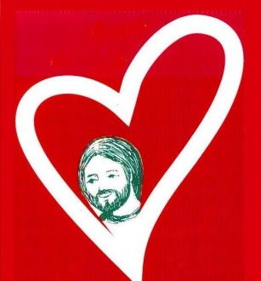
Meeting Jesus in community

Prayer before and / or during the 2019 North American Retreat

- The suggested activity can be lived:
  - in community
  - in a sharing group
  - alone
- If you want to make a shorter activity, you can omit steps 7, 8 and 10.
- The texts (songs, prayer) can be found on the Faith and Sharing website: http://faithandsharing.net/retreat2019.html

Preparation before the meeting:
- A place conducive to meditation, internalized prayer and sharing.
- A person who guides the process.
- A reader of the biblical text.
- A person to lead the songs (and a musician if possible).
- People for the procession of the objects to be deposited.
- Photocopied text of the Gospel or Bibles for each one.
- Text of 1 or 2 songs. Suggestions:
  - Lord Jesus, of you I will sing as I journey
  - Kumbayah
  - Bind us together
- Text "Prayer to prepare for a Faith and Sharing Retreat"
- Some symbols and decorations that would be put in place at step 3 of the process:
  - A Bible and / or Icon of Christ
  - One or more lanterns
  - Incense
  - A green plant or cut flower (s)

Suggested approach:
1 - Take a moment in silence to recollect, to lay down ...
2 - Opening words:
From September 8 to 13, people will make the North American Faith and Sharing Retreat in the Toronto area. They will take time to meet Jesus, and their brothers and sisters listening to the Word, in silence and the sharing groups.
We know the importance of such a retreat. We know that it is the Spirit of Jesus who calls, who acts, who transforms, who heals ...
Let us carry in prayer concretely and not only in thought these future retreatants. Let us ask Jesus that new people, young people too, participate in this retreat.
3 - Sing a known hymn. (See suggestions above)
While being sung, participants come to place the objects: Bible and / or Icon of Christ, etc.
4 – Recollect again: The guide invites us to realize that Jesus is present when we are gathered in his name and that it is He who speaks when we read the Gospel.
5 - Read a biblical story of a meeting between someone and Jesus.
For example: Levi meets Jesus, Mk 2, 13-17
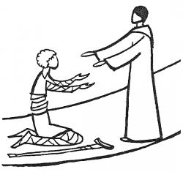
Zacchaeus meets Jesus, Lk 19, 1-10
A leper meets Jesus, Mk 1,38-45
6 - The guide invites you to read alone and to meditate the text:
1 - What does this text say?
2 - What does Jesus tell me in this text?
7 - Contemplate and marvel (in silence) what is happening in this encounter between the character (s) and Jesus.
8 - Give thanks (aloud) for what amazes me in this meeting of the characters of the gospel with Jesus.
9- Thinking about this meeting of Levi or Zacchaeus (or another) with Jesus, share and pray spontaneously for the people who are going to live the retreat "Meeting Jesus in community" in 2019.
10 - Pray together gently (or each paragraph by a different person) the "Prayer to prepare for a Faith and Sharing Retreat".
11 - Let's take a moment of prayer to ask Jesus to help us live our encounters with people in the same way that Jesus lived with all of them. (Those who wish can share their prayer)
12 - After this moment of prayer, the song "???" would be appropriate.
13 - Finish by giving each other the peace of Christ as a sign of fraternal communion.

