North American
Faith and Sharing Retreat
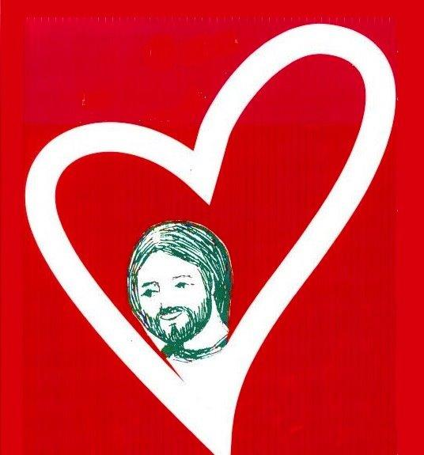

Theme :
Meeting Jesus in community

Location :
Manresa Jesuit Spiritual Renewal Centre
in Pickering, Ontario

Dates: 8 - 13 september, 2019

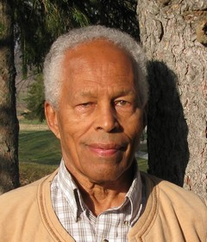

Animator: Bill Clarke SJ

Information and registration (before August 8):
www.faithandsharing.net
or
Isabelle: 613-565-9435

Faith and Sharing is an organization initiated in 1968 with Jean Vanier, founder of L'Arche.

