Animator

We are excited to welcome Bill Clarke SJ as animator for our retreat. Bill entered the Jesuits over 60 years ago and worked for many years at the Ignatius Farm Community working and living with vulnerable people and providing a place of welcome, healing and growth. He has been connected with Faith and Sharing and L’Arche since their beginnings. He continues to live and work at the Ignatius Jesuit Centre in Guelph doing spiritual direction.

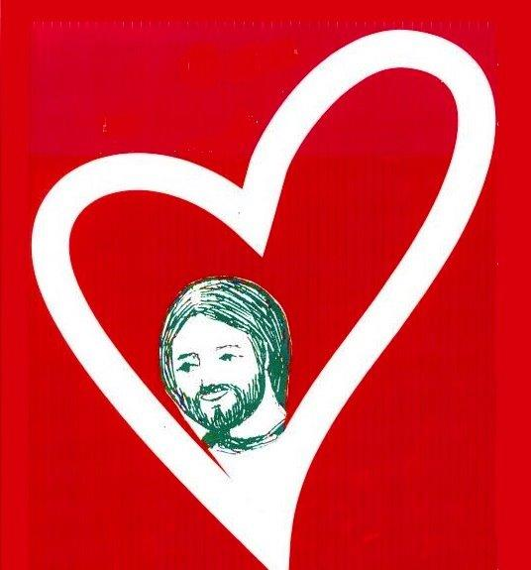
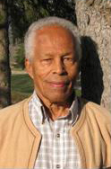

Bill will speak in both English and French. Translation will be provided.

The retreat

The retreat will include 5 days of:
- Inspiring talks
- Daily liturgy and prayer
- Sharing faith in small groups
- Silence and reflection times
- Being with friends old and new
- Opportunities to share with people from other Faith and Sharing communities

Come as you are and be welcomed for who you are

Faith and Sharing North American Retreat

September 8 – 13th 2019

Meeting Jesus in Community

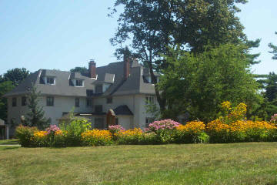

Manresa Jesuit Spiritual Renewal Centre in Pickering, Ontario

What is Faith and Sharing?

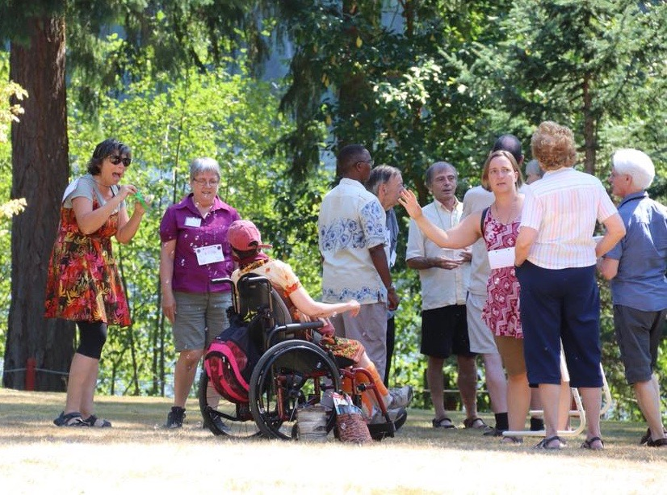

We are excited to announce that the Faith and Sharing Federation North American Committee are planning a Faith and Sharing North American retreat in 2019.

Our goal is to bring together people from every Faith and Sharing community in North America to connect, share, pray together and live the key elements of a traditional 5 day Faith and Sharing retreat.

For more information about the Federation and the different Faith and Sharing communities:
faithandsharing.net

The Facility

Manresa Centre in Pickering, Ontario provides a peaceful and restful environment with grassy areas, beautiful trees and woodlands, and a chapel.
Simple accommodation, nourishing food and a warm welcome await you.

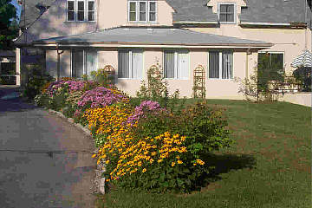

Registration cost for 5 days of accommodation, meals and
daily program will be $515CAN,
or $315CAN for meals and daily program without accommodation.
Subsidies are available.

For more information, about the retreat, contact Claire:
250 898 8322
merryfish@shaw.ca

History of Faith and Sharing

In 1968, Jean Vanier, a former philosophy teacher at a university in Toronto, was invited by the Bishop to give a retreat for priests. At that time, Jean Vanier was living in France where he founded the L’Arche Community, where people with and without disabilities live together. He agreed to give the retreat, but insisted that it not be a retreat solely for priests. He asked it be open to all people from many walks of life, including the disabled and those most vulnerable in our society. From this, Faith and Sharing was born. With Jean’s support, this retreat style flourished across Canada and the United States. He invited people to come together, to form community and to share from their hearts.

